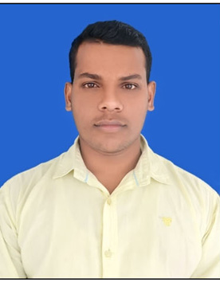
AMARDEEP KASHYAP

D.O.B.: 25-Sep-1994
Nationality: India
Location: Jalalabad, Ghazipur,275202, India
Mobile: +91 9838961624
Email: amardeepkashyap44@gmail.com
Indian Passport No: R4940178

OBJECTIVE
To be reliable professional and contribute to the accomplishment of the goals of organization.

EDUCATION
SMRD PG COLLEGE, Ghazipur, Uttar Pradesh, India
PG POLITICAL Sci. (VBSPU, Jaunpur) June 2017

LANGUAGES

English – Excellent reading, writing and speaking
Hindi – Excellent reading, writing and speaking

SPECIALIZED SKILLS
- Excellent interpersonal and communication skills
- Multi-tasking abilities with proficiency in organizing and managing different tasks
- Expert knowledge of handling administration and paperwork
- Skilled in book keeping and preparing statistical and financial records
- Thorough insights in overseeing stock levels and ordering supplies
- Proficient in assigning duties and scheduling shifts
- Ability of recruiting, training and supervising staff
- Expert marketing skills to promote business

OTHER INTERESTS
Cricket, Football, Reading Newspaper, Bike Riding, Watching YouTube Videos & News, Gadgets freak

THANKS

AMARDEEP KASHYAP

